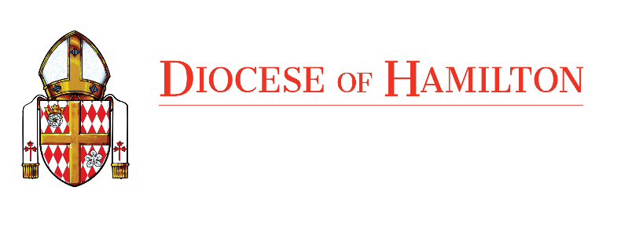

Director of Cemeteries

The Catholic Cemeteries of the Diocese of Hamilton is looking for a Director of Cemeteries to manage our nineteen Diocesan Cemeteries, seven Mausoleums and two Crematoriums.

The Catholic Cemeteries is a wholly owned subsidiary of The Roman Catholic Episcopal Corporation of the Diocese of Hamilton in Ontario which was established in 1856 and is the second largest diocese in English speaking Canada which serves the needs of more than 626,000 Roman Catholics throughout Southwestern Ontario.

Ideally the Director of Cemeteries should be a person with experience in a leadership role within the bereavement industry, have five to seven years of Cemetery experience. Knowledge of the operational responsibilities of a crematorium and transfer service and Funeral Home operations would be an asset to the candidate. Knowledge of the Funeral, Burial and Cremation Services Act and the Bereavement Association of Ontario is required.

The Director position is a multi-disciplinary role. The ideal candidate should possess the following characteristics and abilities:

- Experience managing a mid size organization.
- Knowledge of Catholic Burial traditions and requirements.
- Supervision of staff.
- Familiarity with Health and Safety requirements.
- Familiarity with Human Resource requirements in the Province of Ontario.
- Excellent communication abilities, both written and oral.
- Proficiency in understanding Financial Reports.
- Experience in dealing with external agencies (auditors, governmental agencies, etc.)
- Comfortable presenting to diverse groups (bereavement professionals, religious groups, various committees).

This position leads a diverse group of individuals including Senior Managers, Sales & Counselling staff, Crematorium operators, outside workers, and various administration and accounting roles. The Director is expected to mentor employees as to allow for succession planning.

The Director is also expected to be able to provide guidance and steer the operation with a view towards the long-term success of the organization. The Director should be familiar with the challenges related to managing a mid size non-profit organization that is totally self funding. Long term planning needs to encompass serving the Catholic community with its burial requirements. This includes balancing meeting the needs of the ever-changing demographics of the Catholic community while at the same time ensuring the long-term financial viability of the organization.

If this sounds like you, and you’re looking for a great work environment, please apply at: carrers@hamiltondiocese.com.

We thank all candidates for their interest, however, only those selected for an interview will be contacted.

The Diocese of Hamilton is an equal opportunity employer and is committed to fostering an inclusive and accessible work environment. If you are contacted for an interview and require accommodation, please inform the Human Resources Manager.

